Operating Systems – Lab 09
Name: Hafsa Salman
Roll no. 22K-5161

Task no. 01
Code:
#include<stdio.h>
#include<stdlib.h>
#include<unistd.h>
#include<signal.h>
#include<time.h>

#define SIZE 10
#define DELAY 200000

volatile sig_atomic_t interrupt = 0;
volatile int arr[SIZE];

void print()
{
for (int i=0; i<SIZE; i++)
{
printf("%d ", arr[i]);
}

printf("\n");
}

void handle_sigint (int sig)
{
interrupt = 1;
}

int main()
{
srand(time(NULL));

for (int i=0; i<SIZE; i++)
{
arr[i] = rand() % 100;
}

printf("Array: ");
print();

struct sigaction sa;

sa.sa_handler = handle_sigint;
sigemptyset(&sa.sa_mask);
sa.sa_flags = 0;
sigaction(SIGINT, &sa, NULL);

for (int i=0; i<SIZE-1; i++)
{
for (int j=0; j<SIZE-i-1; j++)
{
if (interrupt)
{
printf("\nSignal Received! Array: \n");
print();
interrupt = 0;
}

if (arr[j] > arr[j+1])
{
int temp = arr[j];
arr[j] = arr[j+1];
arr[j+1] = temp;

usleep(DELAY);
}
}
}

printf("\nSorted Array: \n");
print();

return 0;
}

Output:
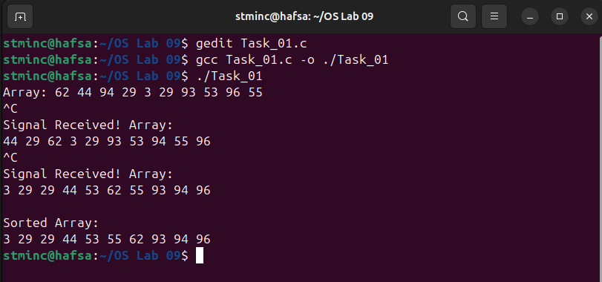

Task no. 02
Code:
#include<stdio.h>
#include<stdlib.h>
#include<unistd.h>
#include<signal.h>
#include<sys/stat.h>
#include<sys/types.h>
#include<time.h>

volatile sig_atomic_t interrupt = 0;

void handle(int sig)
{
interrupt = 1;
}

int main()
{
pid_t pid;

struct sigaction sa;
sa.sa_handler = handle;
sigemptyset(&sa.sa_mask);
sa.sa_flags = 0;

sigaction(SIGUSR1, &sa, NULL);

pid = fork();

if (pid < 0)
{
perror("Fork Failed!");
exit(0);
}

if (pid == 0)
{
sleep(1);
printf("Child sending signal to parent! \n");

kill(getppid(), SIGUSR1);
exit(0);
}

else
{
printf("Parent waiting for the signal from child!\n");

while(!interrupt)
{
pause();
}

char folder[50];
int num = rand() % 100;
snprintf(folder, sizeof(folder), "folder_@#$%d", num);

if (mkdir(folder, 0777) == 0)
{
printf("Parent created folder %s\n", folder);
}

else
{
perror("Failed to create folder");
}
}

return 0;
}

Output:
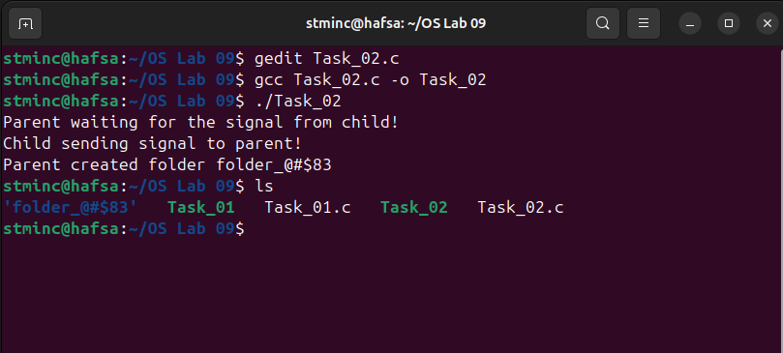

Task no. 03
Code:
#include<stdio.h>
#include<stdlib.h>
#include<pthread.h>
#include<signal.h>
#include<unistd.h>
#include<sys/syscall.h>

#define gettid() syscall(SYS_gettid)
#define NUM_THREADS 4
pthread_t threads[NUM_THREADS];

void sigusr1_handler (int signum)
{
int i = gettid(), j = getppid(), k = getpid();

fprintf(stdout, "Thread %lu received SIGUSR1 signal (parent = %u) [pid = %u] {tid = %u} \n", pthread_self(), j, k, i);
}

void *thread_function(void *args)
{
while(1) sleep(1);
return NULL;
}

int main()
{
signal(SIGUSR1, sigusr1_handler);
for (int i=0; i < NUM_THREADS; ++i)
{
if (pthread_create(&threads[i], NULL, thread_function, NULL) != 0)
{
perror("pthread_create");
exit(EXIT_FAILURE);
}
}

int i=gettid(), j=getpid(), k=getppid();

fprintf(stdout, "Parent Process ID: %u, Process ID: %u, main() thread ID: %u\n", k, j, i);

fprintf(stdout, "Thread IDs: 0 = %lu, 1 = %lu,\n", threads[0], threads[1]);
kill(j, SIGUSR1);
pthread_kill(threads[1], SIGUSR1);

for (int i=0; i<NUM_THREADS; ++i)
{
if (pthread_join(threads[i], NULL) != 0)
{
perror("pthread_join");
exit(EXIT_FAILURE);
}
}

return 0;
}

Output:
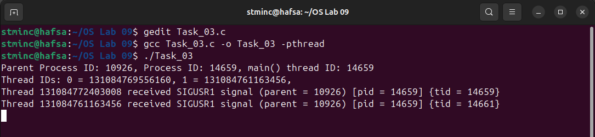

Code Workout 2 - Modified
Code:
#include<stdio.h>
#include<signal.h>
#include<stdlib.h>
#include<unistd.h>
#include<sys/wait.h>
#include<sys/resource.h>

void proc_exit()
{
int wstat;
pid_t pid;

while(1)
{
pid = wait3(&wstat, WNOHANG, NULL);

if (pid == 0 || pid == -1)
{
fprintf(stdout, "Return value of wait3() is %d\n", pid);
return;
}

fprintf(stdout, "Return code: %d\n", wstat);
}
}

int main()
{
signal(SIGCHLD, proc_exit);

for (int i=0; i<3; i++)
{
switch(fork())
{
case -1:
perror("Main: Fork");
exit(0);

case 0:
printf("I am alive temporarily\n");
int ret_code = rand();
printf("Return Code: %d\n", ret_code);
exit(ret_code);

default:
pause();
}
}

while(1)
{
pause();
}

return 0;
}

Output:
